EDM Unit 10 Study Guide
- Draw the lines of symmetry.

- Count by 1’s. 3,447, 3,448, ____, ____, ____, ____, ____, ____

- Mark the temperature 4. Write the temperature
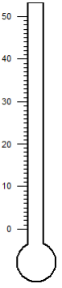
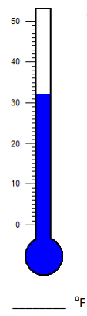
to show 47 degrees F. shown on the thermometer.

- Find the rule and complete the “What’s my Rule?” Table.
Rule
in | out
250 | 300
425 | 475
400
 | 550

EDM Unit 10 Study Guide
Use coins and bills. Write the amount.
- 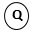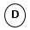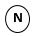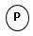 = $ ____
- = $ ____

Fill in the blanks. Write ones, tens, hundreds or thousands.
- The 4 in 4,621 stands for 4 __________.
- The 6 in 3,568 stands for 6 __________.
10. The 3 in 7,394 stands for 3 __________.

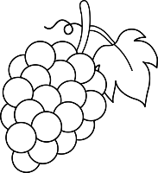
11. You buy
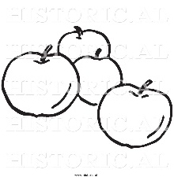
Apples and Grapes
1 lb at $1.78 1 bunch at $3.07

- Estimate the total cost.
Estimated cost: $ ___ + $ ___ = $ ___
- Use a calculator. Find the exact cost. Write the amount in dollar and cents notation.
Exact Cost: $ _____
12. You buy a bottle of juice for $3.16. You give the cashier $5.00. How much change should you get? Show your work.

13. 4 people share 20 cookies. How many cookies does each person get?
______
Show your work.

