EDM Unit 11 Study Guide

- Ahmed had $4.00. He spent $3.75.
How much change should Ahmed get? ________

- Reem had $5.00. She spent $3.40.
How much change should Reem get? ________

- Draw a picture or use counters to solve.
24 pennies shared equally among 6 children.

How many pennies does each child get? ________

Draw an array to solve each problem.

- 3 x 7 = _________

- 4 x 6 = _________

- 5 x 2 = _________

Add or subtract.
- $1.60 8. $3.37 9. $2.42 10. $3.15
- $0.27 + $1.24 - $2.17 +$4.07
EDM Unit 11 Study Guide

Write > (greater than),< (less than) or = (equal to).
11. ______ 13. 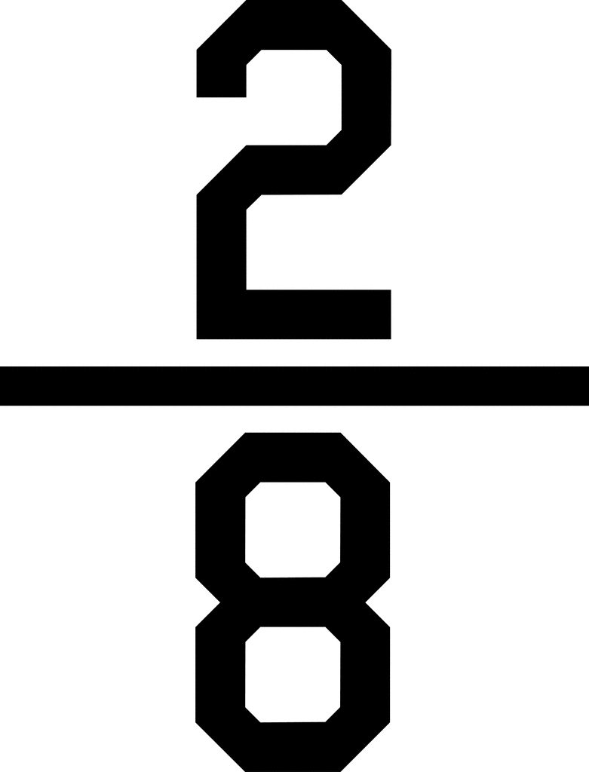______

12. 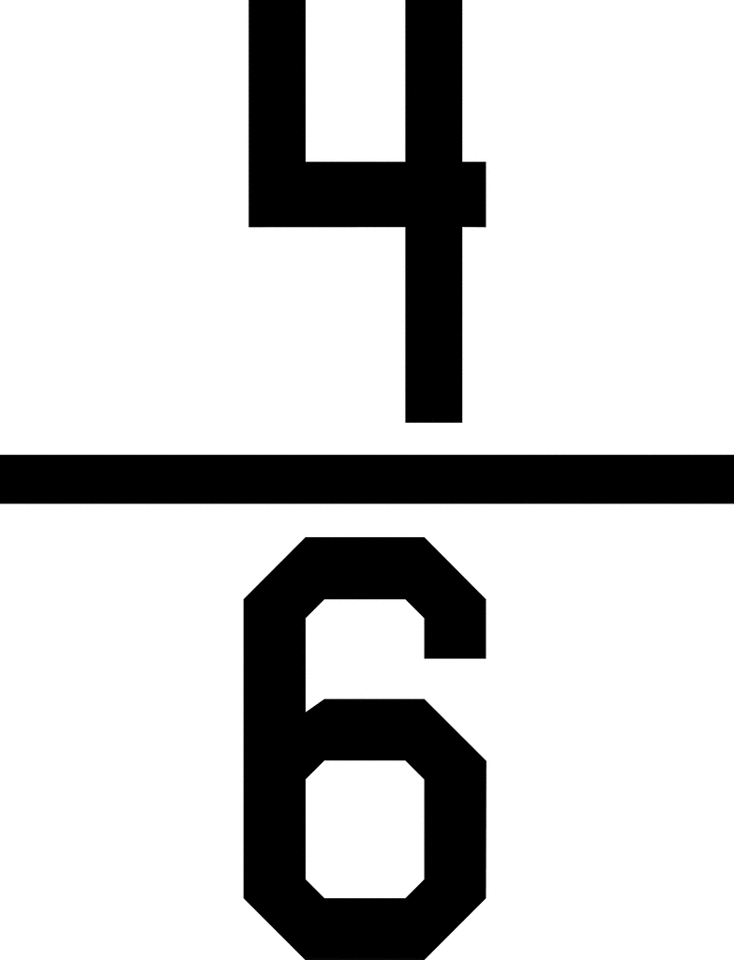______ 14. 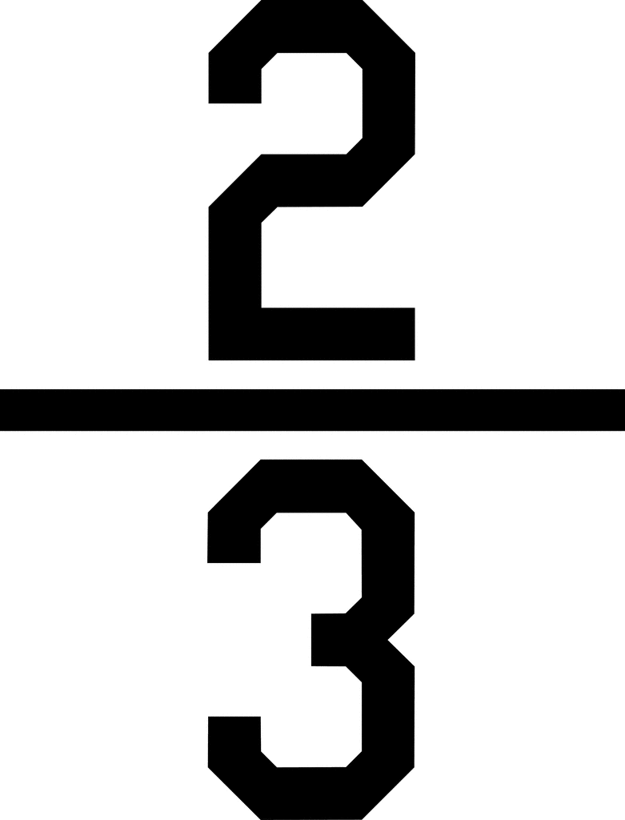______

For each number story, fill in a multiplication/division diagram. Then use counters, arrays, or pictures to find the answer.

17. 6 boxes 18. 3 bags of cups
4 balls in each box 12 cups in all
How many balls in all? _____ How many cups in each bag? ____
boxes | balls per basket | balls in all |  | bags | cups per bag | cups in all

Number model: ____________ Number model: _____________

Use counters, a number grid, or pictures to find your answer. Show your work. Record your answer.
15. 35 16. 42
+47 - 17

