- Write the fact family.
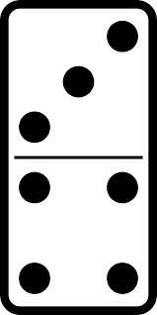
____________________________ ____________________________
____________________________ ____________________________

- Fill in the counts.
1,396, 1397, ________, ________, ________, ________, ________, ________.

- Write the numbers from least to greatest.
851 752 524 1,368
______ ______ ______ ______

- Draw two line segments using your ruler.
D E

G H

- What is this shape?
- hexagon
- rhombus
- square

- What is this shape?
- rectangle
- triangle
- trapezoid

- Name these shapes.
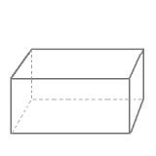
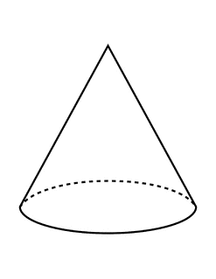
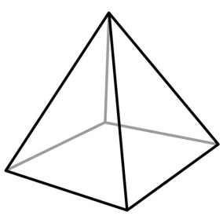

- Draw two parallel line segments.
(remember that all line segments have names )

- Draw two line segments that are not parallel.
