EDM Unit 6 Study Guide
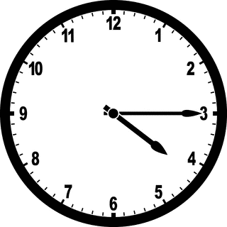
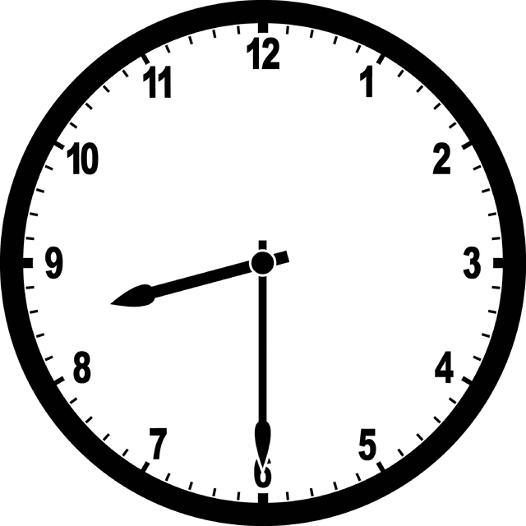
- Write the time.

___:___ ___:___
- Fish A weighs 25 kilograms. Fish B weighs 10 kilograms. How much do they weigh together?
________________________
Total

Part | Part

- Write <,> or =. 4. Solve.
Rule
In | Out
3 | 7
7
10
 | 11
35 ___ 53
410___401
229___259

5. Make ballpark estimates. Write a number model for each estimate.
67+29 31+48 152+61=
___+___=___ ___+___=___ ___+___=___
6. Draw an array with 6 rows and 4 dots in each row.
How many dots in all?
Number Model :_____________

Quantity
27
Quantity  17 | Difference
7. Abdulla scores 27 points in basketball. Ahmed scores 17. How many more points did Abdulla score?
_______ points more

8. Solve.
A. 56 B. 34 C. 87 D. 170
- 31 - 19 -49 - 34

