EDM Unit 8 Study Guide

1. Which shows 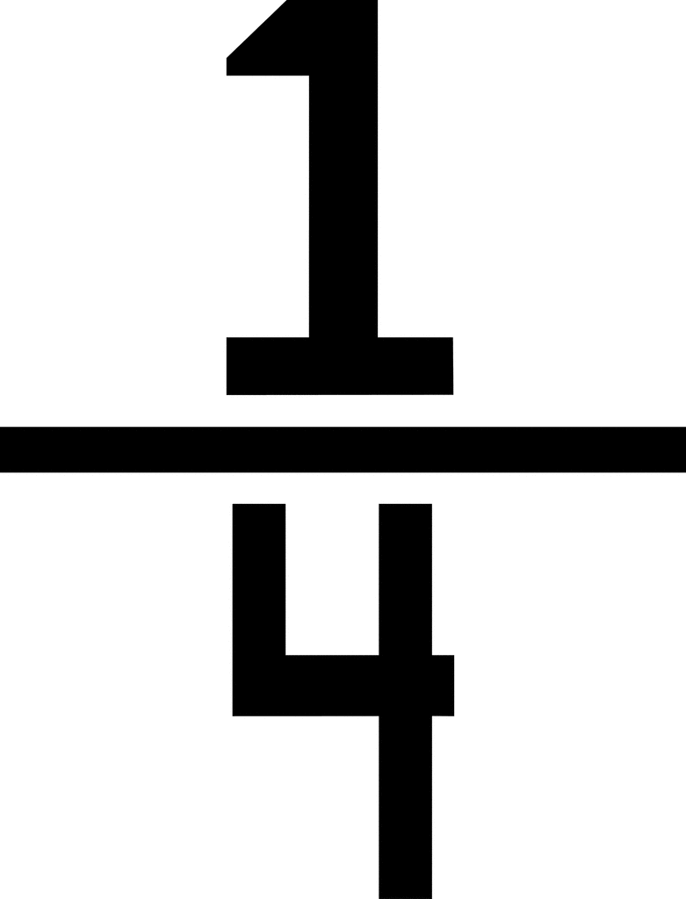 shaded? Fill in the oval.
2. Which fraction shows how much is shaded? Fill in the oval. 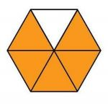 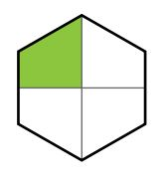

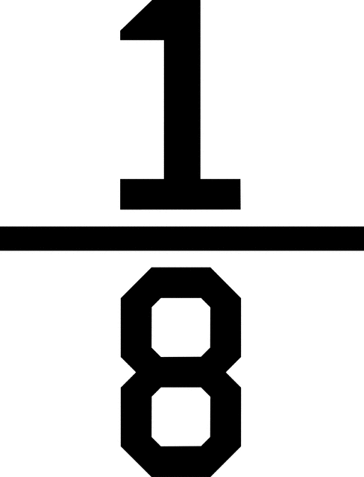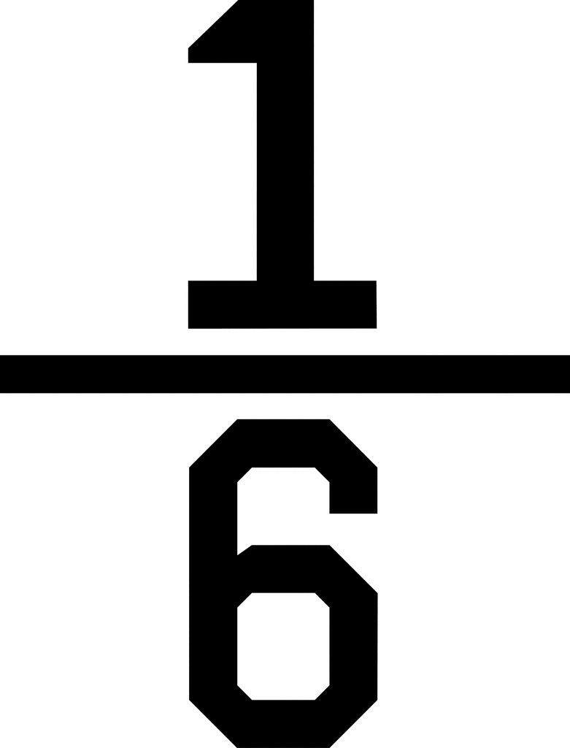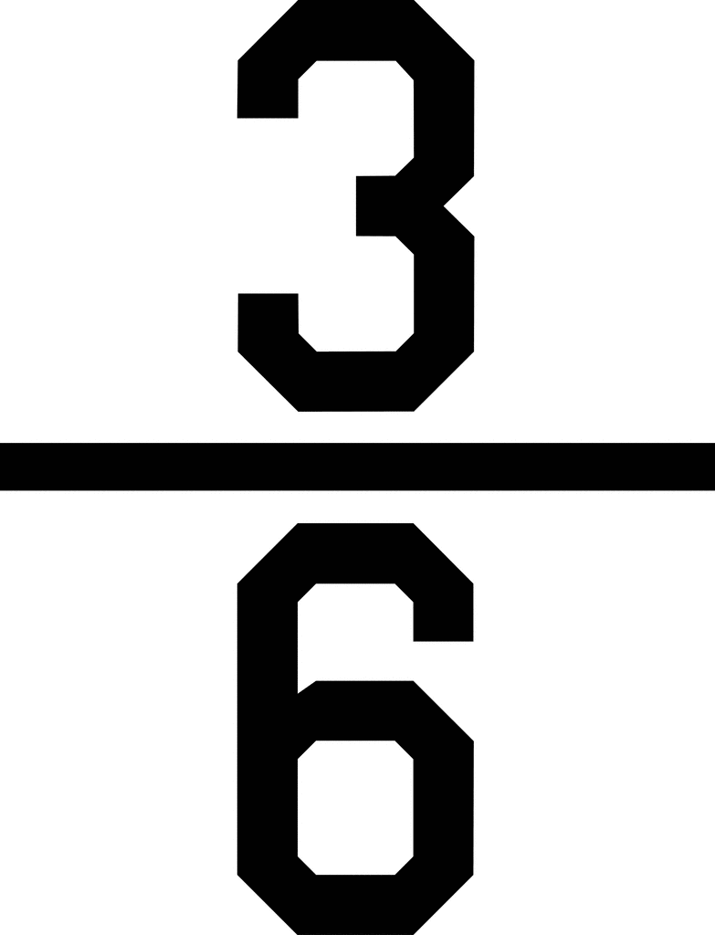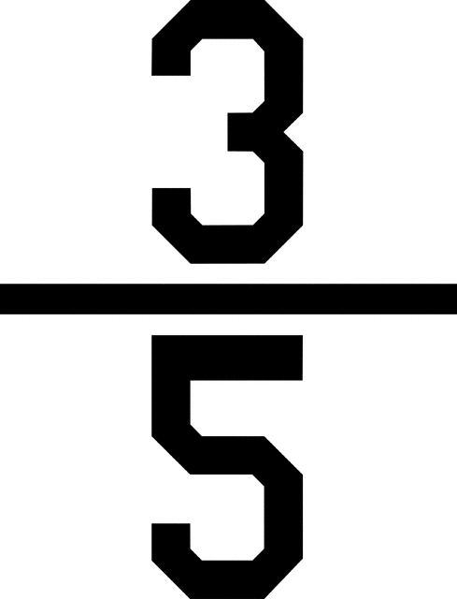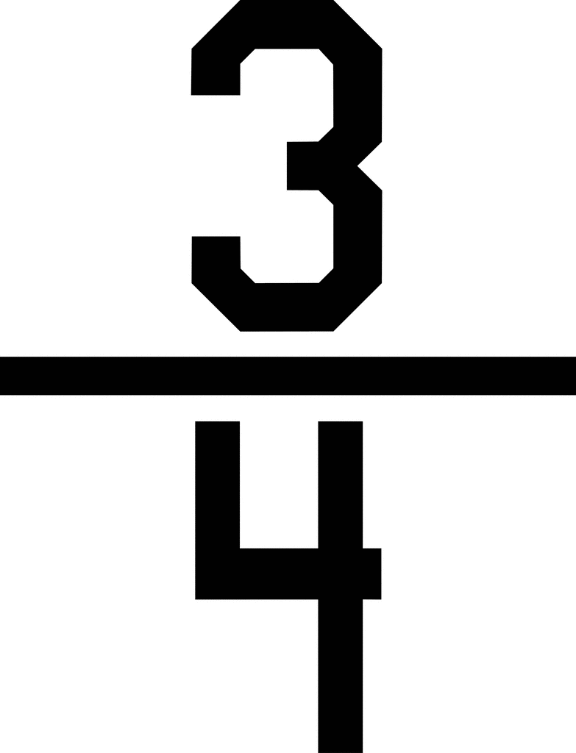

1. 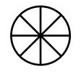 Color 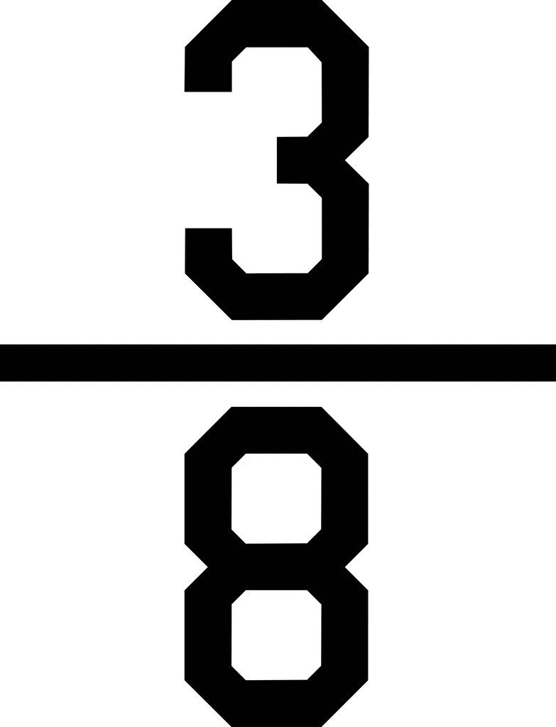.

EDM Unit 8 Study Guide

1. Color 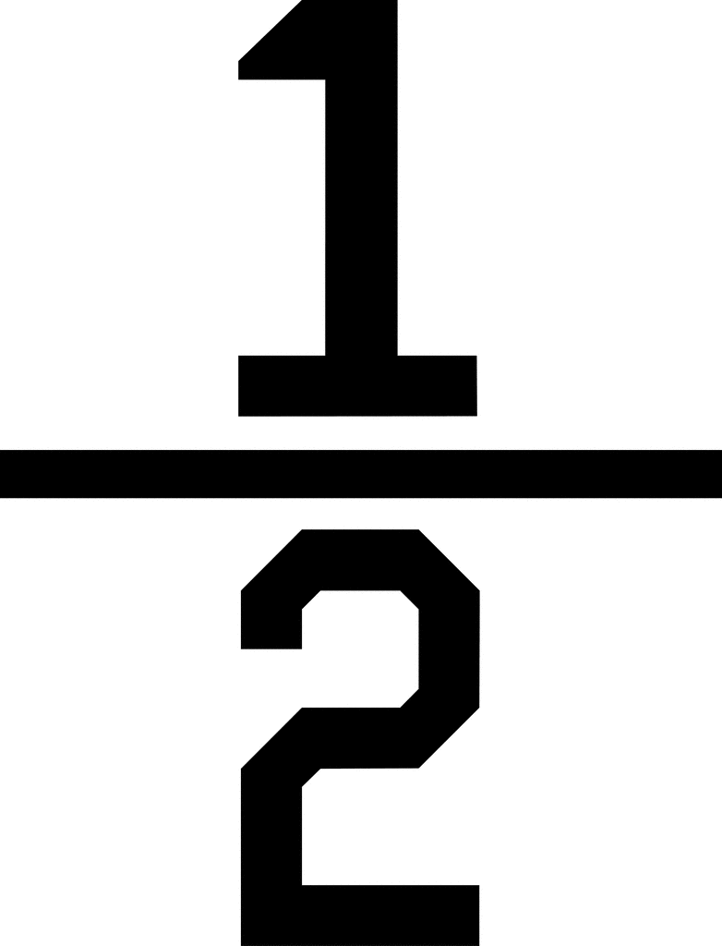. 5. Color 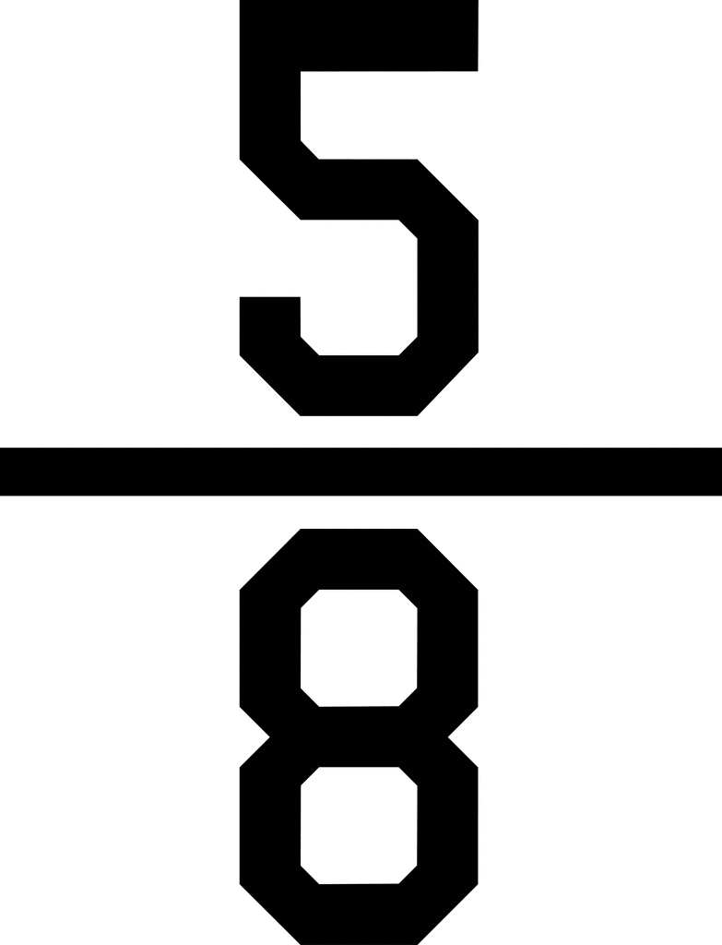.

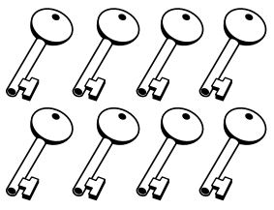

1. Write one thing you are sure will happen today.

______________________________________________

1. Write one thing you are sure will NOT happen today.

______________________________________________

1. Which drawing has a line of symmetry? Fill in the ovals.

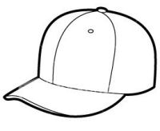

EDM Unit 8 Study Guide

1. 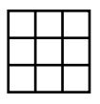Color 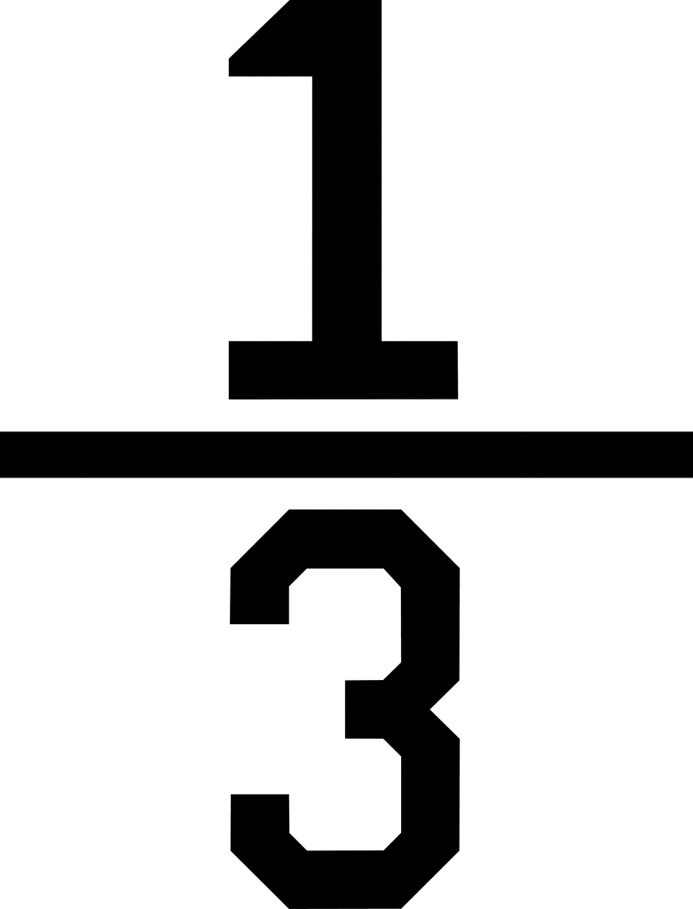.
2. a. Divide into :

Halves Fourths

Write <, >, or =.

b.  ___ c. 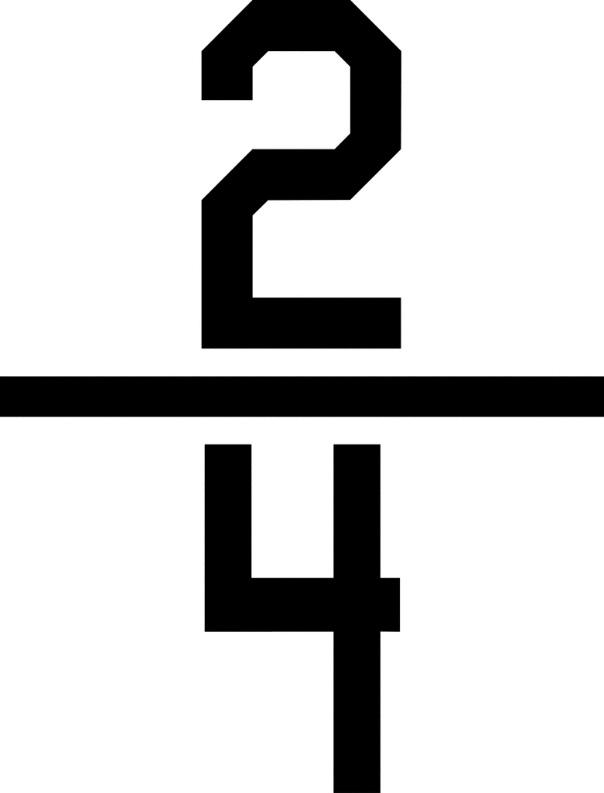___

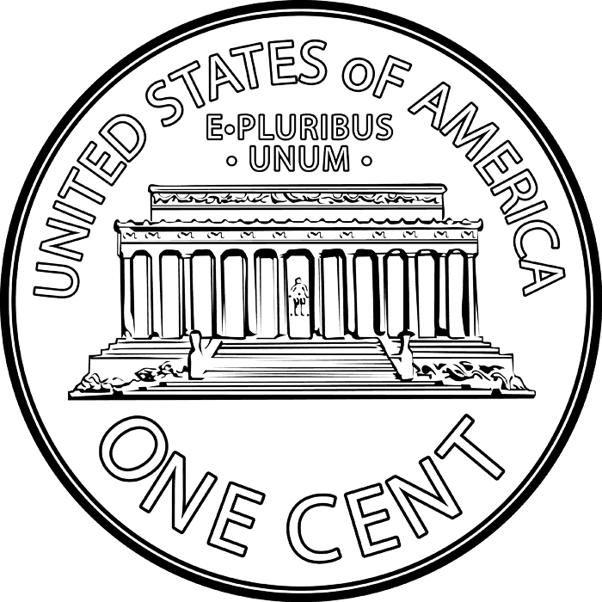

1. a. Four people share 8

pennies equally. How

many pennies does each

person get?_________

b. 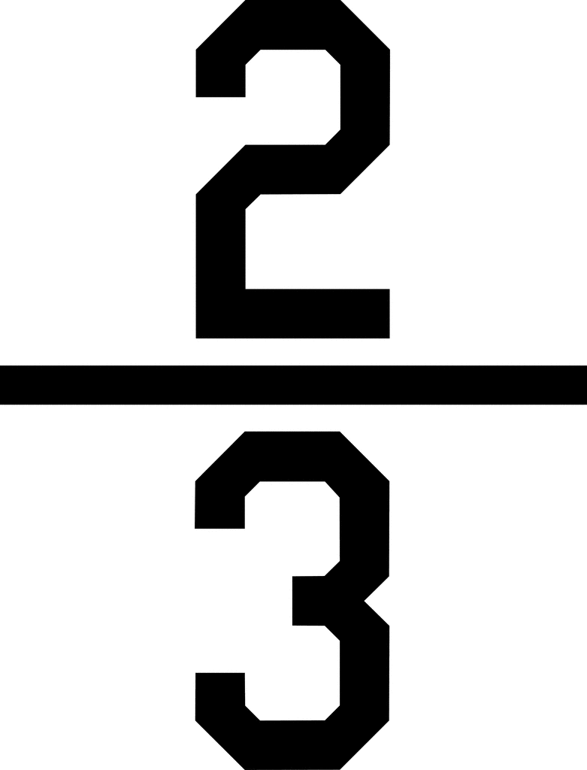of the pennies equals? _______



12. Use counters to solve. There are 12 cookies. of them are chocolate chip. How many are chocolate chip? ______________