EDM Unit 9 Study Guide

Measure each line segment to the nearest inch and centimeter.

____ inches
____ centimeters

____ inches
____ centimeters

Find the area of each shape.

- 4.

Area = _____ sq cm Area = _____ sq cm

- Draw line segment EF.

EDM Unit 9 Study Guide

- Make a ballpark estimate. Write a number model for the estimate.
26
+ 57 ____ + ____ = ____

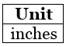
- 47, 48, 49, 50, 51
The median number of inches is ____.

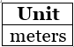
- 13, 6, 9, 12, 15, 7, 10
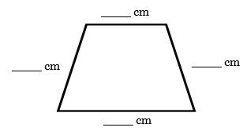
The median number of meters is ____.

- Measure the sides of the
trapezoid to the nearest centimeter.

10. Write another name for . ______

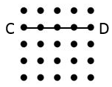
11. Draw a line segment that is
parallel to line segment CD.
Label its endpoints RS.

12. 42 13. 77 14. 96 15. 85
+ 63 +36 - 54 - 28

