Money Review
1 Dollar | 25 cents | 10 cents | 5 cents | 1 cent
100 cents | 4 quarters in 1 dollar | 10 dimes in 1 dollar | 20 nickels in 1 dollar | 100 pennies in 1 dollar
$___.___
Dollars Cents
Counting Money
Use coins and bills. Write the amount.
- = $______

- = $ ______

- = $______

- = $______

- = $ ______

Estimating Cost
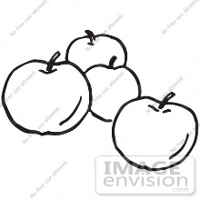
You buy:
Apples and Grapes
1 lb at $1.32 lb 1 bunch at $2.07

Estimate the total cost:
Estimated Cost: $ ____ + $ ____ = $ ____

