- How much money?
P
N
D
D
Q

- What is the temperature 3. Mark each thermometer to
on the thermometer? show the temperature:
25
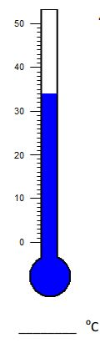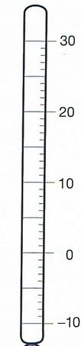
- 49 = ______ tens _____ ones

- Are the numbers odd or even?
- 38 _____ b. 27 _____
c. 169 _____ d. 324 _____
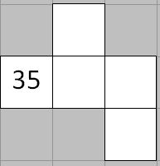
- Fill in the grid.

- Maitha bought a pack of gum for 42 cents. She paid with 2 quarters. How much change did she get back? _________

- Circle the digit in the 100s place.
- 4,359 b. 19,433 c. 429

- Hamda brought 27 biscuits to school for National Day. She gave 10 away. How many biscuits does she have now?
Change
End
Start

----------
Answer: _______________
Number Model: ________________
Make a ballpark estimate. Write a number model to show your estimate. Next, solve. Show your work.

- Estimate: 11. Estimate:
- __________ a. _________
- 35 b. 62
+ 41 + 49

