- Shamma made 20 cakes for the class party. She gave 15 of them away.

- How many cakes does Shamma have left?
______________________________________________________ (units) (What are they counting?)
- Number Model:

__________________________________________________________

- Use the data from the table to make a bar graph.
Weight of 2nd Graders
Weight of 2nd Graders
Weight | Number
32Kg | 1
33kg | 0
34kg | 2
35kg | 5
Number of 2nd Graders

- Find the rule
10
5
10
20
Rule
15
30
20
40

25
50

- Name these shapes.
- Pyramid
- Cone
- Cylinder
- Rectangular prism
- Sphere
- Pyramid
- Cone
- Cylinder
- Rectangular prism
- Sphere
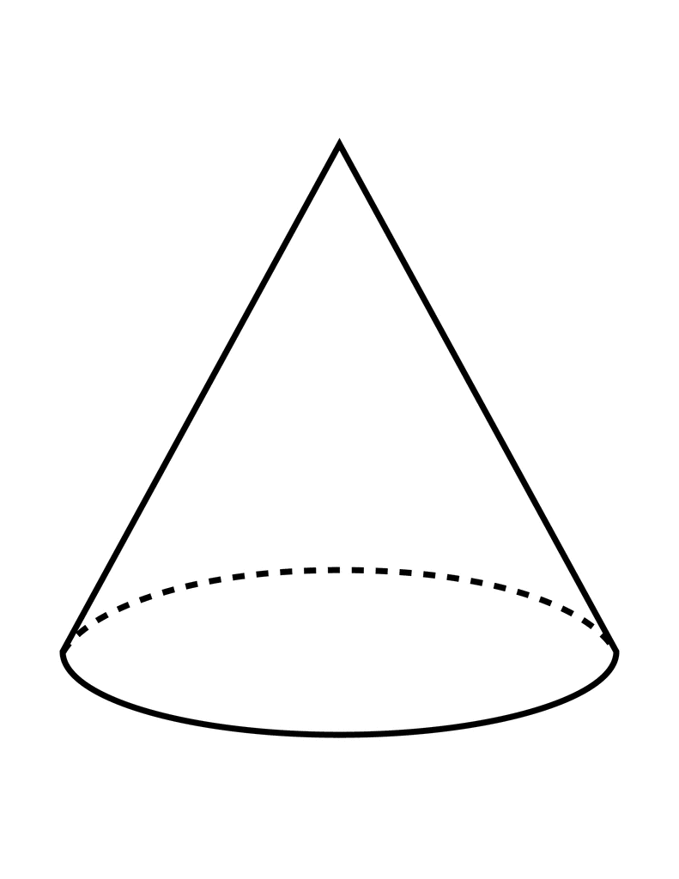
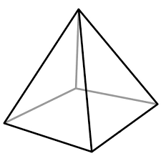
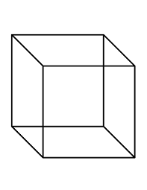
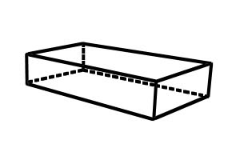
- Pyramid
- Cone
- Cylinder
- Rectangular prism
- Sphere
- Pyramid
- Cone
- Cylinder
- Rectangular prism
- Sphere

- Find the median (middle number ) and the mode (most often number).
a) 2,4,6, ______________________________ (median)
b) 2,4,6,8,10 ___________________________ (median)

c) 62,48,24,62,44 ____________________________ (mode)
d) 2,5,6,4,2,2,9,8,7 ___________________________ (mode)

- What is half of these numbers? (divide by 2)

- 60 =
- 10 =
- 20 =
- 40 =

2,052
- Fill in the missing numbers.

